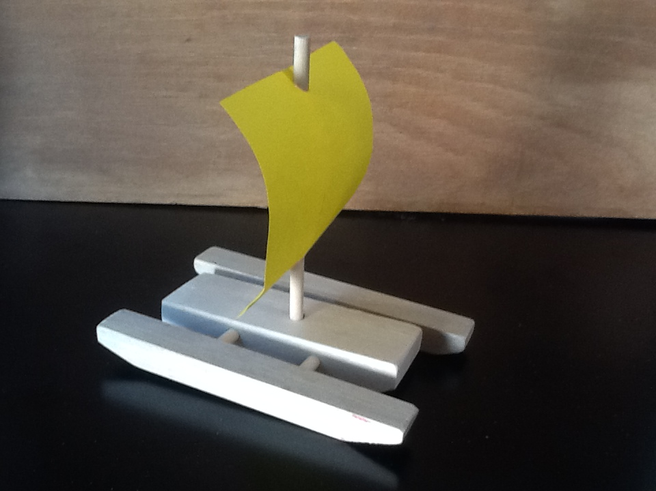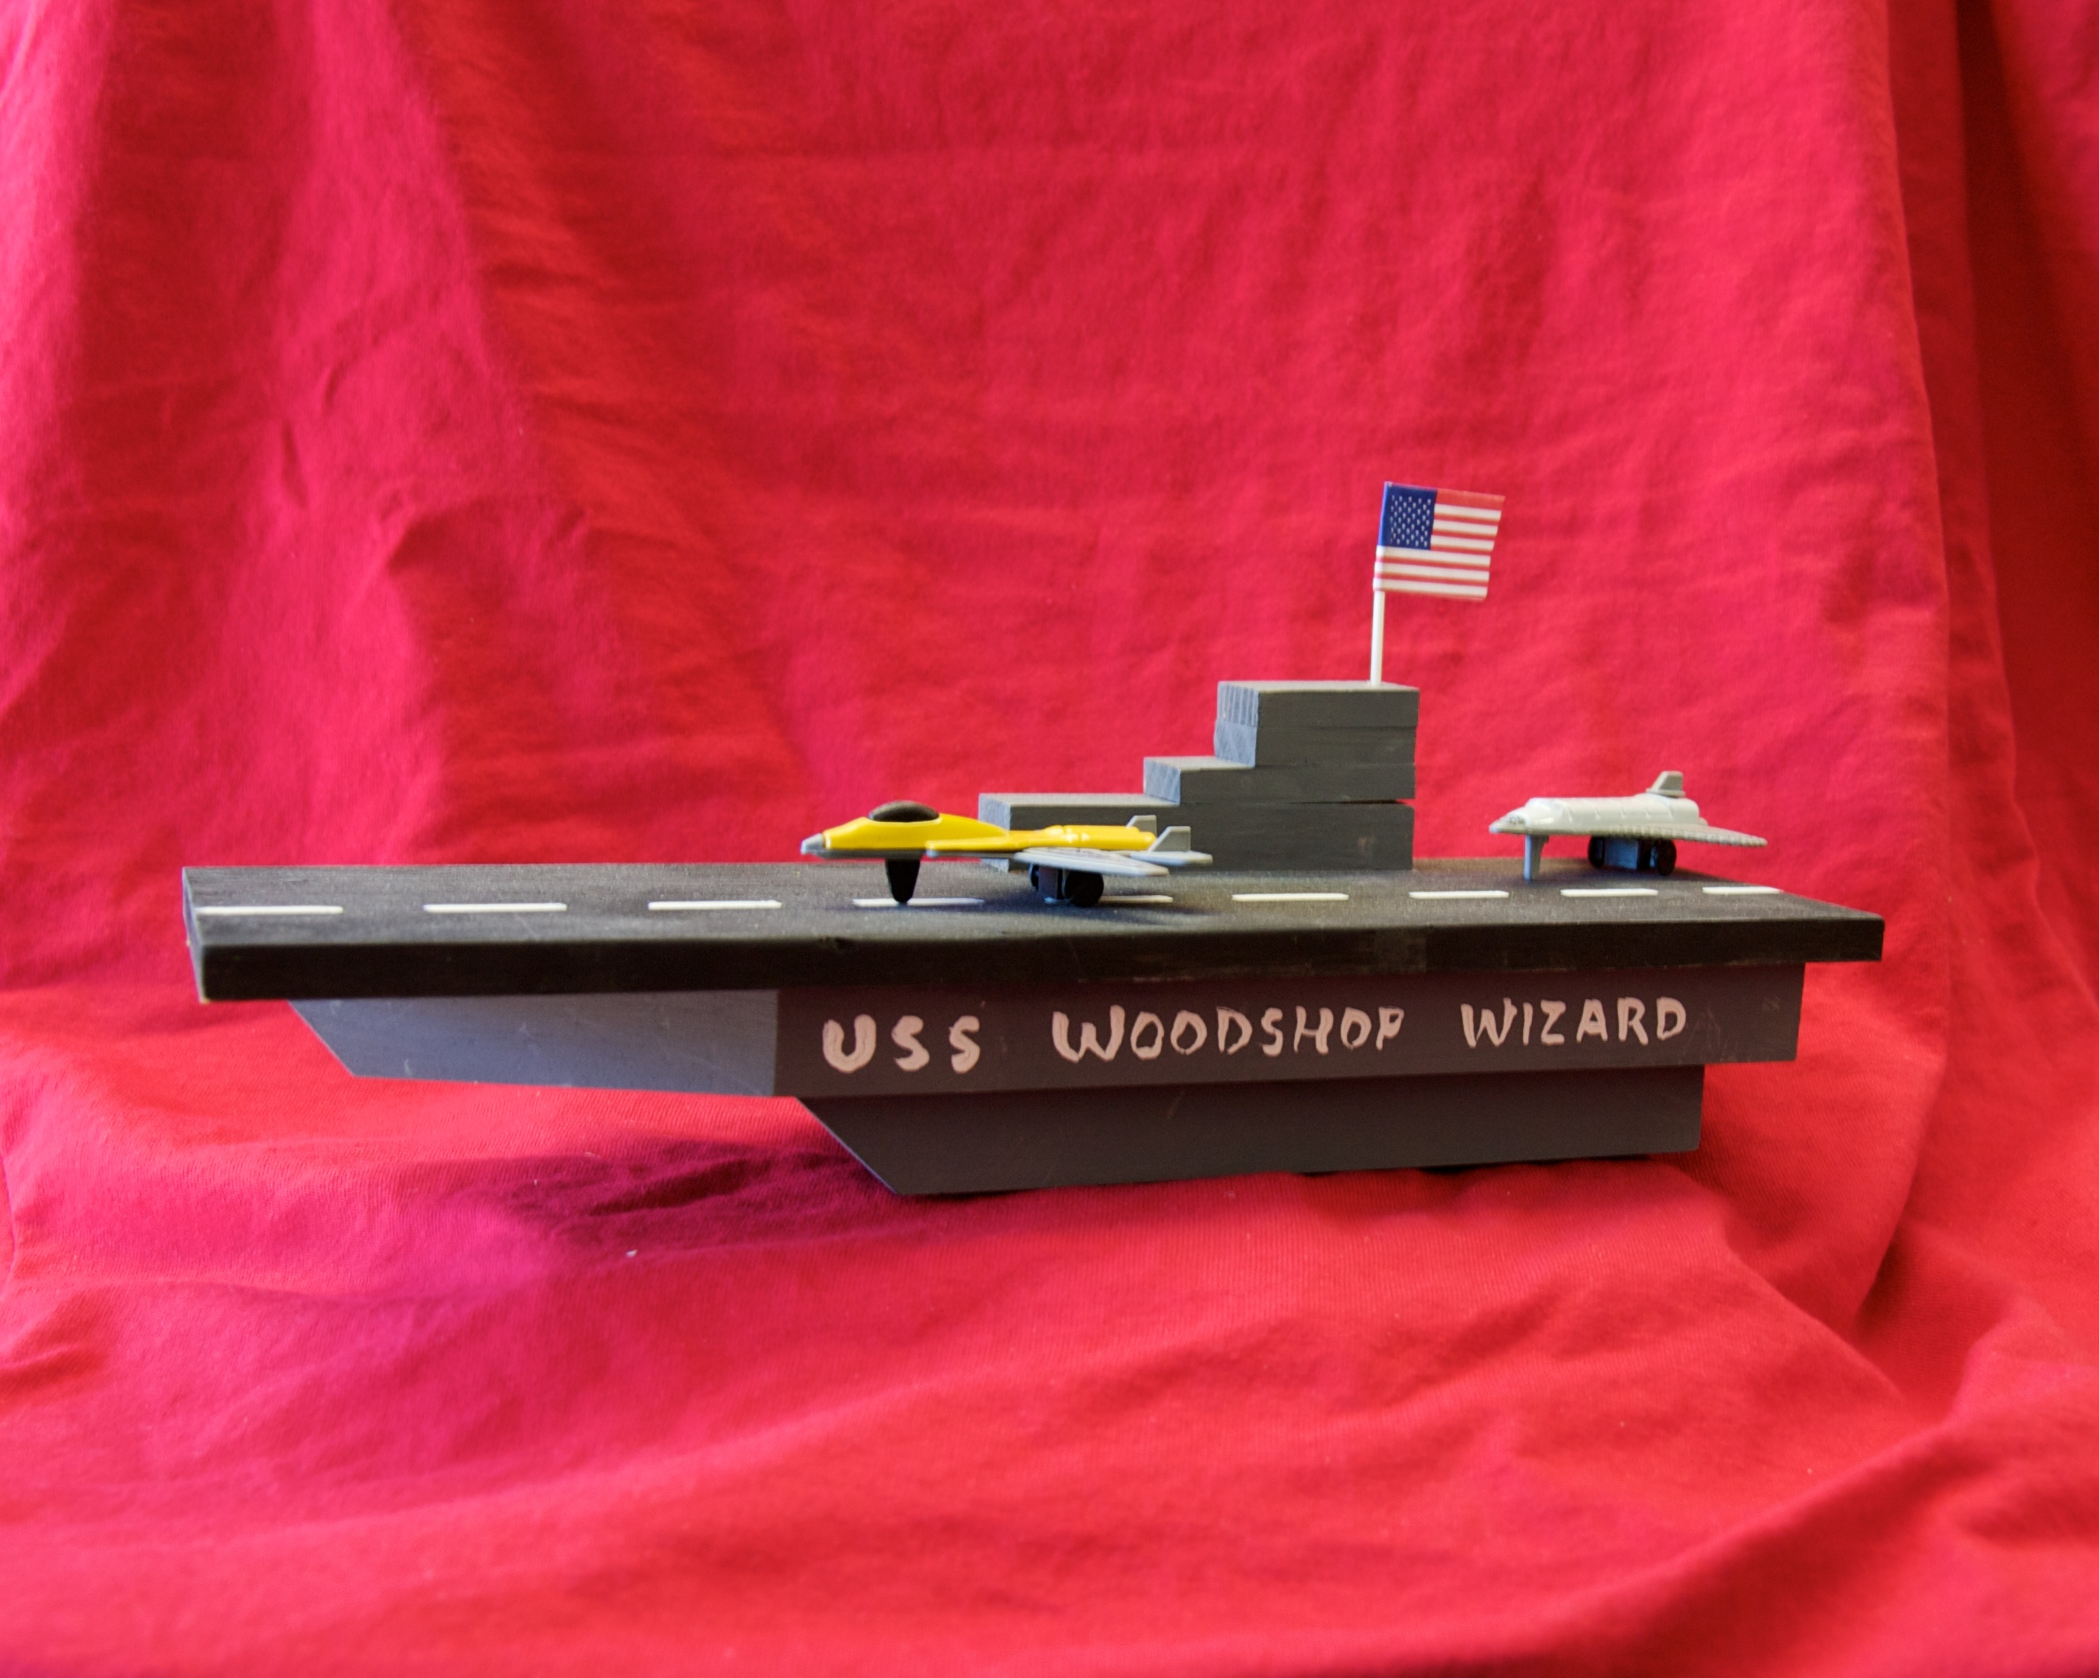

**8 WEEKS OF WOODWORKING**

**$130 Includes All Materials**

SESSION STARTS – JANUARY 23, 2017

GRADES: 1st through 5th

WHEN: Mondays

TIME: 2:50pm TO 3:50pm

Dates: 1/23, 1/30, 2/6, 2/13, 2/27, 3/6, 3/13, 3/20

Note: No Class: 2/20 & Class early on: 3/20 (half day)

Location: Lunch Tables

Register & Pay Online at www.JuniorBuildersAcademy.com

**Build These Wood Projects & More This Session!!**

**Aircraft Carrier, Army Tank, Catamaran**

**WOODSHOP WIZARDS**

**AN AFTER SCHOOL PROGRAM FROM JUNIOR BUILDER’S ACADEMY**

**ALBERT EINSTEIN ACADEMY**

REGISTER & PAY ONLINE AT: [WWW.JUNIORBUILDERSACADEMY.COM](http://WWW.JUNIORBUILDERSACADEMY.COM)

Checks can be mailed: P.O. Box 2574, La Mesa 91943

Registration must be completed online.

A learning experience teaching basic woodworking skills and the use of essential hand tools.

More Info At :

[www.JuniorBuildersAcademy.com](http://www.JuniorBuildersAcademy.com)

or Call 619 749 7534