OpenMinds on Albert Einstein Campus
Family Learning for Global Living
www.OpenMindsLearnBest.com ~ 619-665-1264

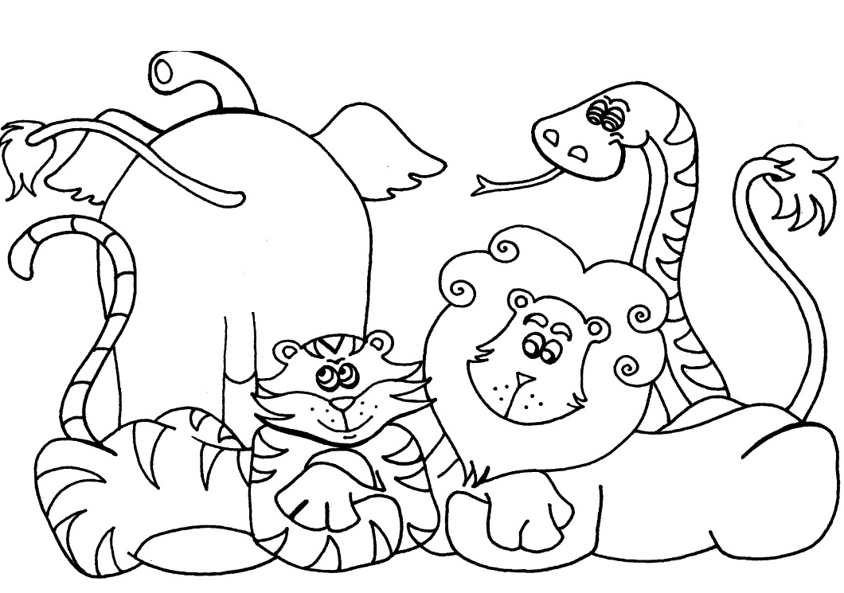
Thursdays ArtSpace: Animal Art

2:50-3:50 (12:35-1:35 on 3/23)
1/19/17 – 3/23/17
$158 (10 weeks)
Great for grades K-5 on Albert Einstein Campus
This session the theme for ArtSpace is Animal Art. Students will build art skills, work with a wide variety of mediums, and have fun experimenting with different art tools while they create a collection of unique and interesting animals. We are creating new lessons just for this session! Each class weaves in a life skill discussion, which is tied to the class theme for that day, helping the students to explore both art and life through that topic. ArtSpace is designed to increase artistic expression, self-awareness and social skills.

Fridays
Jr. Design & Engineering

2:50-3:50 (12:35-1:35 on 3/24, no class 2/17)
1/20/17 – 3/24/17
$139 (9 weeks)
Great for grades K-5 on Albert Einstein campus
Come and build with us! From Lego cars, marble tracks, ancient clay pyramids, and structures made out of all kinds of fun recycled materials, this class puts creativity and fun in the front seat as your students learn about principles of building, design and engineering. This hands-on class allows students to experience the cause and effects of gravity, friction, stability, structure, and basic mechanics. With lots of room for their own creativity and design ideas, each project is a wonderful adventure for your young engineers!
Register Online: www.OpenMindsLearnBest.com
By Email: cdamico3@gmail.com
By Phone: 619.665.1264
By registering my child, I certify that my child is in normal health and capable of participating. I acknowledge the risk of injury is possible. Safety is the first concern in all OpenMinds classes, but unforeseen in juries can occur. Given that, I grant permission for my child to participate and in so doing so hereby release OpenMinds and it’s staff from all liability to me for any loss or damage to property or physical injury. If medical attention is required, I give permission for such care when either I or the child’s doctor cannot be reached. OpenMinds is not responsible for the cost incurred for any medical care. Checks made payable to: OpenMinds
Student’s Name: ____________________________________________________
Grade: _____ Teacher: __________________ Classroom #_________
Pick Up/Drop Off Notes: _________________________________________________
Contact Email: _________________________________________________________
Parent/Guardian Name:_______________________ __________________________
Main Phone #__________________ Alternate Phone #_____________________
Credit Card# _________________________________CVV________ Exp. Date: _______
Mailing Address: ______________________________________________________
City & Zipcode: __________________________________________
Albert Einstein Academies

