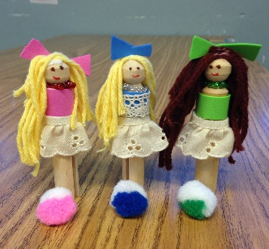
German Arts & Crafts Classes
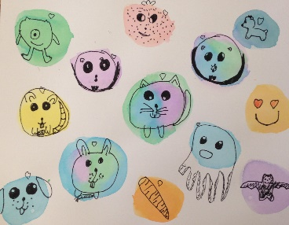
With Britta Hyde and Sonja Griffin
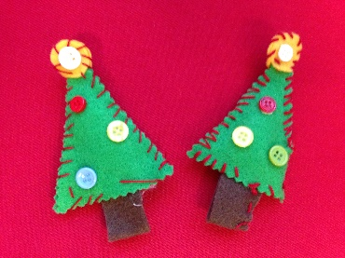
- Every week a new fun project to create and keep
- Learn about German culture and traditions
- Enhance German language skills through bilingual instructions
- Improve cognitive development, fine motor skills and creativity

For: Grade 1-5
Time: Tuesday, 2:50 pm-4:00 pm, starting 1/17
Cost: $150 for ten sessions (1/17-3/24)
all materials are included
Registration: e-mail germancrafts2015@gmail.com or call 619-701-3454

